1,2,3,4) Simple regular expression

import re as r;

str =*'Welcome to python class'*

print(r.findall(*' '*, str))

print(r.search(*' '*, str))

print(r.split(*' '*, str))

print(r.sub(*' '*,*'-'*, str))

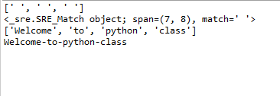

*5) 5.1 set Operation (specified char)*

import re as r;

print(*'set Operation (specified char)'*)

str =*'Welcome to python class'*

print(r.findall(*'[mec]'*, str))

print(r.search(*'[mec]'*, str))

print(r.split(*'[mec]'*, str))

print(r.sub(*'[mec]'*,*'-'*, str))

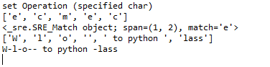

5.2 Inter value ([a-h])

import re as r;

print(*'set Operation (inter value)'*)

str =*'Welcome to python class'*

print(r.findall(*'[a-h]'*, str))

print(r.search(*'[a-h]'*, str))

print(r.split(*'[a-h]'*, str))

print(r.sub(*'[a-h]'*,*'-'*, str))

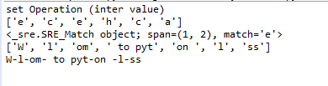

*5.3 set Operation ([^me])*

import re as r;

print(*'set Operation ([^me])'*)

str =*'Welcome to python class'*

print(r.findall(*'[^me]'*, str))

print(r.search(*'[^me]'*, str))

print(r.split(*'[^me]'*, str))

print(r.sub(*'[^me]'*,*'-'*, str))

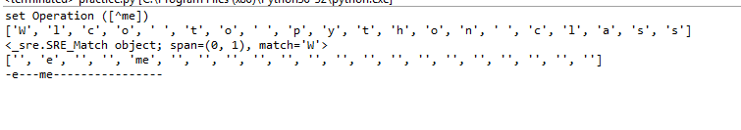

*5.4 set Operation ([5])*

import re as r;

print(*'set Operation ([5])'*)

str =*'Welc5ome to pyt5hon class'*

print(r.findall(*'[5]'*, str))

print(r.search(*'[5]'*, str))

print(r.split(*'[5]'*, str))

print(r.sub(*'[5]'*,*'-'*, str))

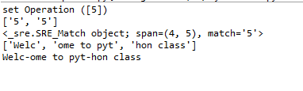

*5.5 set Operation ([0-6])*

import re as r;

print(*'set Operation ([0-6])'*)

str =*'Welc0-6ome to pyt0-6hon class'*

print(r.findall(*'[0-6]'*, str))

print(r.search(*'[0-6]'*, str))

print(r.split(*'[0-6]'*, str))

print(r.sub(*'[0-6]'*,*'-'*, str))

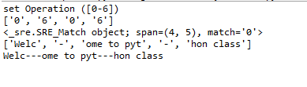

*5.6 set Operation ([A-Z])*

import re as r;

print(*'set Operation ([A-Z])'*)

str =*'WelcA-Zome to pytA-Zhon class'*

print(r.findall(*'[A-Z]'*, str))

print(r.search(*'[A-Z]'*, str))

print(r.split(*'[A-Z]'*, str))

print(r.sub(*'[A-Z]'*,*'-'*, str))

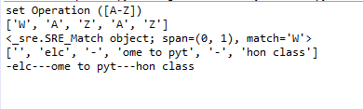

*5.7 set Operation ([A-Z a-z 0-9])*

import re as r;

print(*'set Operation ([A-Z a-z 0-9])'*)

str =*'WelcAZome to pytAZhon&% class'*

print(r.findall(*'[A-Z a-z 0-9]'*, str))

print(r.search(*'[A-Z a-z 0-9]'*, str))

print(r.split(*'[A-Z a-z 0-9]'*, str))

print(r.sub(*'[A-Z a-z 0-9]'*,*'-'*, str))

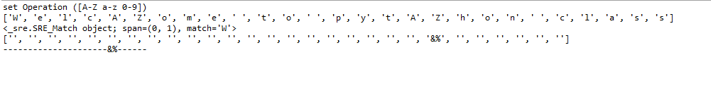

*6) 6.1 backslash Operation (\AWel)*

import re as r;

print(*'backslash Operation (\AWel)'*)

str =*'WelcAZome to pytAZhon&% class'*

print(r.findall(*'\AWel'*, str))

print(r.search(*'\AWel'*, str))

print(r.split(*'\AWel'*, str))

print(r.sub(*'\AWel'*,*'-'*,str))

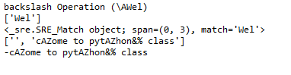

*6.2 backslash Operation (\bass)*

import re as r;

print(*'backslash Operation (\bass)'*)

str =*'WelcAZome to pytAZhon&% class'*

print(r.findall(*r'\bass'*, str))

print(r.search(*r'\bass'*, str))

print(r.split(*r'\bass'*, str))

print(r.sub(*'r\bass'*,*'-'*,str))

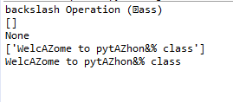

*6.3 backslash Operation (\Bass)*

import re as r;

print(*'backslash Operation (\Bass)'*)

str =*'WelcAZome to pytAZhon&% class'*

print(r.findall(*'\Bass'*, str))

print(r.search(*'\Bass'*, str))

print(r.split(*'\Bass'*, str))

print(r.sub(*'\Bass'*,*'-'*,str))

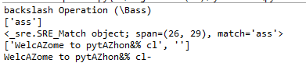

*6.4 backslash Operation (\dass)*

import re as r;

print(*'backslash Operation (\dass)'*)

str =*'WelcAZ4ome to pytAZhon&% class'*

print(r.findall(*'\d'*, str))

print(r.search(*'\d'*, str))

print(r.split(*'\d'*, str))

print(r.sub(*'\d'*,*'-'*,str))

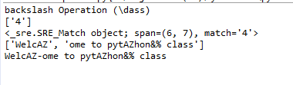

*6.5 backslash Operation (\Dass)*

import re as r;

print(*'backslash Operation (\Dass)'*)

str =*'WelcAZ4ome to pytAZhon&% class'*

print(r.findall(*'\D'*, str))

print(r.search(*'\D'*, str))

print(r.split(*'\D'*, str))

print(r.sub(*'\D'*,*'-'*,str))

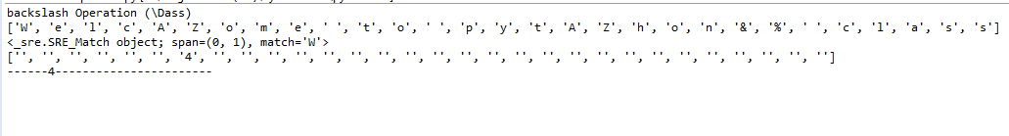

*6.6 backslash Operation (\sass)*

import re as r;

print(*'backslash Operation (\sass)'*)

str =*'WelcAZ4ome to pytAZhon&% class'*

print(r.findall(*'\s'*, str))

print(r.search(*'\s'*, str))

print(r.split(*'\s'*, str))

print(r.sub(*'\s'*,*'-'*,str))

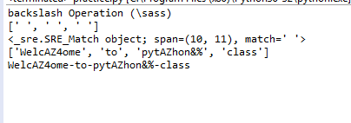

*6.7 backslash Operation (\Sass)*

import re as r;

print(*'backslash Operation (\Sass)'*)

str =*'WelcAZ4ome to pytAZhon&% class'*

print(r.findall(*'\S'*, str))

print(r.search(*'\S'*, str))

print(r.split(*'\S'*, str))

print(r.sub(*'\S'*,*'-'*,str))

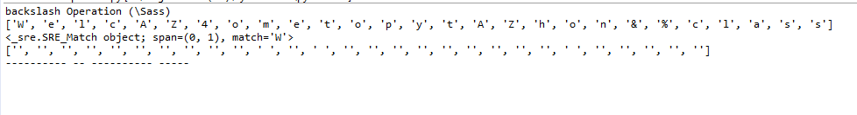

*6.8 backslash Operation (\wass)*

import re as r;

print(*'backslash Operation (\wass)'*)

str =*'WelcAZ4ome to pytAZhon&% class'*

print(r.findall(*'\w'*, str))

print(r.search(*'\w'*, str))

print(r.split(*'\w'*, str))

print(r.sub(*'\w'*,*'-'*,str))

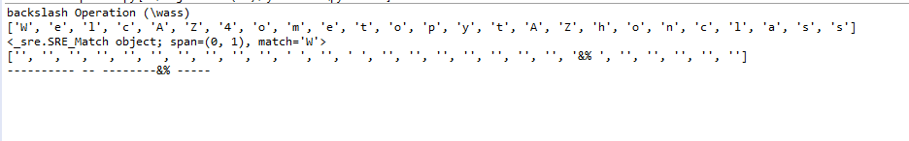

*6.9 backslash Operation (\Wass)*

import re as r;

print(*'backslash Operation (\Wass)'*)

str =*'WelcAZ4ome to pytAZhon&% class'*

print(r.findall(*'\W'*, str))

print(r.search(*'\W'*, str))

print(r.split(*'\W'*, str))

print(r.sub(*'\W'*,*'-'*,str))

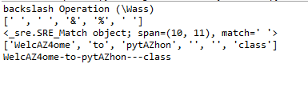

*6.10 backslash Operation (ass\Zass)*

import re as r;

print(*'backslash Operation (ass\Zass)'*)

str =*'WelcAZ4ome to pytAZhon&% class'*

print(r.findall(*'ass\Z'*, str))

print(r.search(*'ass\Z'*, str))

print(r.split(*'ass\Z'*, str))

print(r.sub(*'ass\Z'*,*'-'*,str))

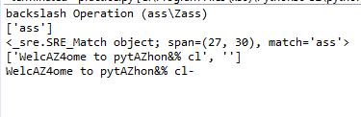

*7. dot Operation (c..e)*

import re as r;

print(*'dot Operation (c..e)'*)

str =*'Welcome to python class'*

print(r.findall(*'c..e'*, str))

print(r.search(*'c..e'*, str))

print(r.split(*'c..e'*, str))

print(r.sub(*'c..e'*,*'-'*,str))

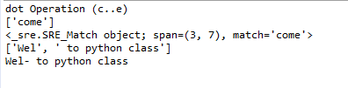

*8. start with Operation (^W)*

import re as r;

print(*'start with Operation (^W)'*)

str =*'Welcome to python class'*

print(r.findall(*'^W'*, str))

print(r.search(*'^W'*, str))

print(r.split(*'^W'*, str))

print(r.sub(*'^W'*,*'-'*,str))

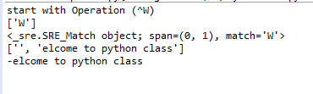

*9. find Operation (ass$)*

import re as r;

print(*'find Operation (ass$)'*)

str =*'Welcome to python class'*

print(r.findall(*'ass$'*, str))

print(r.search(*'ass$'*, str))

print(r.split(*'ass$'*, str))

print(r.sub(*'ass$'*,*'-'*,str))

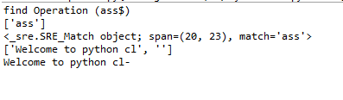

*10. zero or more Operation (ss\*)*

import re as r;

print(*'zero or more Operation (ss\*)'*)

str =*'Welcome to python class'*

print(r.findall(*'ss\*'*, str))

print(r.search(*'ss\*'*, str))

print(r.split(*'ss\*'*, str))

print(r.sub(*'ss\*'*,*'-'*,str))

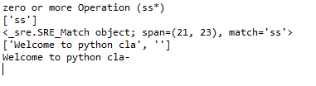

*11. one or more Operation (ss+)*

import re as r;

print(*'one or more Operation (ss+)'*)

str =*'Welcome to python class'*

print(r.findall(*'ss+'*, str))

print(r.search(*'ss+'*, str))

print(r.split(*'ss+'*, str))

print(r.sub(*'ss+'*,*'-'*,str))

